Background Materials on the Richard B. Russell Dam

History
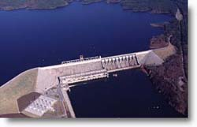 | Richard B. Russell Dam and Lake, a multipurpose project constructed under the supervision of the Savannah District, U. S. Army Corps of Engineers, was authorized for construction by the 1966 Flood Control Act as Trotters Shoals Lake, later renamed to commemorate a late senator from Georgia, Richard B. Russell. The authorization document outlined the plan of development for the basin with authorized purposes of power production, incidental flood control, recreation, additional stream flow regulation, water supply, and fish and wildlife management. Permanent filling of the reservoir began in October 1983 and reached full pool of 26,650 acres at elevation 475 msl in December 1984. The first of four conventional units came on line and began producing power in January 1985.
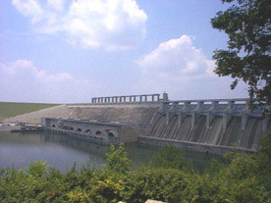

Richard B. Russell Dam and Lake
Construction began in 1974 and was completed in 1986 for the construction of the 1,800-foot concrete dam and hydropower plant. The total capacity for all eight units, as of the year 2000, with the addition of pumped storage was 600 MW, each with a rated capacity of 75 MW. As mitigation for the impacts of the Richard B. Russell impoundment, an underwater Oxygen Injection System has been installed upstream of the dam. This system is designed to provide a minimum of 5 parts per million of dissolved oxygen in the tailrace of the Russell power plant from summer through early fall of each year.
Richard B. Russell is the largest Corps-owned plant east of the Mississippi River, consisting of eight units, four of which are pumped storage units. Pumped storage facilitates the reuse of the water to meet peak demands by pumping back during off peak periods, such as at night. The pumped storage component provides 300 MW of the total capacity.
Pump back operation is currently restricted to two pump units from June through September for environmental reasons during the peak summer season, while there is the greatest electrical demand. This pumping restriction will be lifted once a new oxygen injection system is built in J. Strom Thurmond Lake downstream of the Russell dam near Modoc, South Carolina. This oxygen injection system is a mitigation feature to offset the potential thermal impacts to the tail-water fishery downstream of the Richard B. Russell dam. Four unit pumping in the summertime increases tail-water temperatures to around 27 degrees centigrade which is above the comfort range for striped bass. The cost of the oxygen injection system is $5.5 million and will take three years to complete once it is initially funded.
In addition to providing increased hydropower capacity and energy, pumped storage is most effective as a water management tool that conserves water for reuse for hydropower, municipal and industrial water supply, recreation, and the environment. During times of drought significant water conservation can be realized through the use of pumped storage. The pumping capacity of each of the four units is 7,200 cubic feet per second (cfs); the four pumped storage units pumping for six hours per night will move over 14,000 acre / feet from Thurmond lake back into Russell lake for reuse. This total volume equates to 4.6 billion gallons per night.
The currently installed capacity of the Richard B. Russell Project is four 75,000-kilowatt conventional generator units (numbered one through four), for a total of 300 megawatts. The addition of four 75,000 kilowatt pump turbine generator units (numbered five through eight) will double the rated power capacity of the Russell plant to 600 megawatts.

